**Name Vedant goswami**

**Exercise: 5**

# Flow chart for main method:

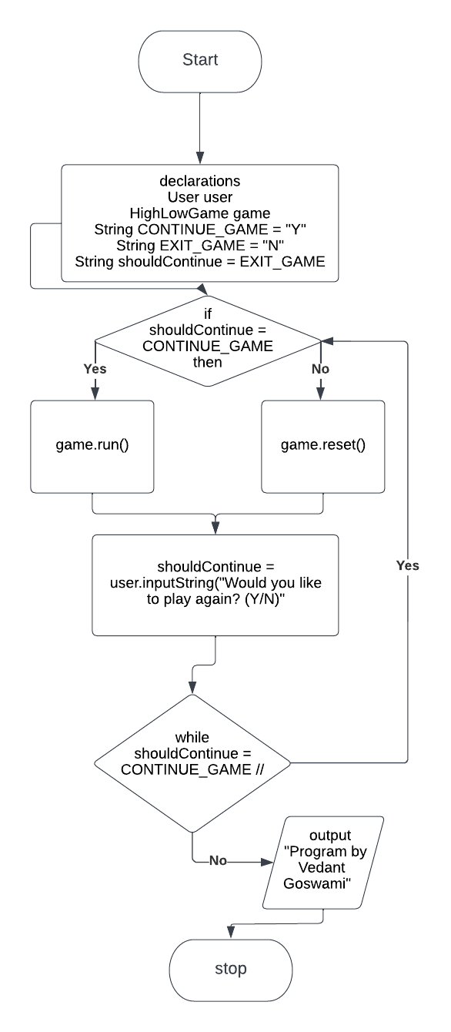

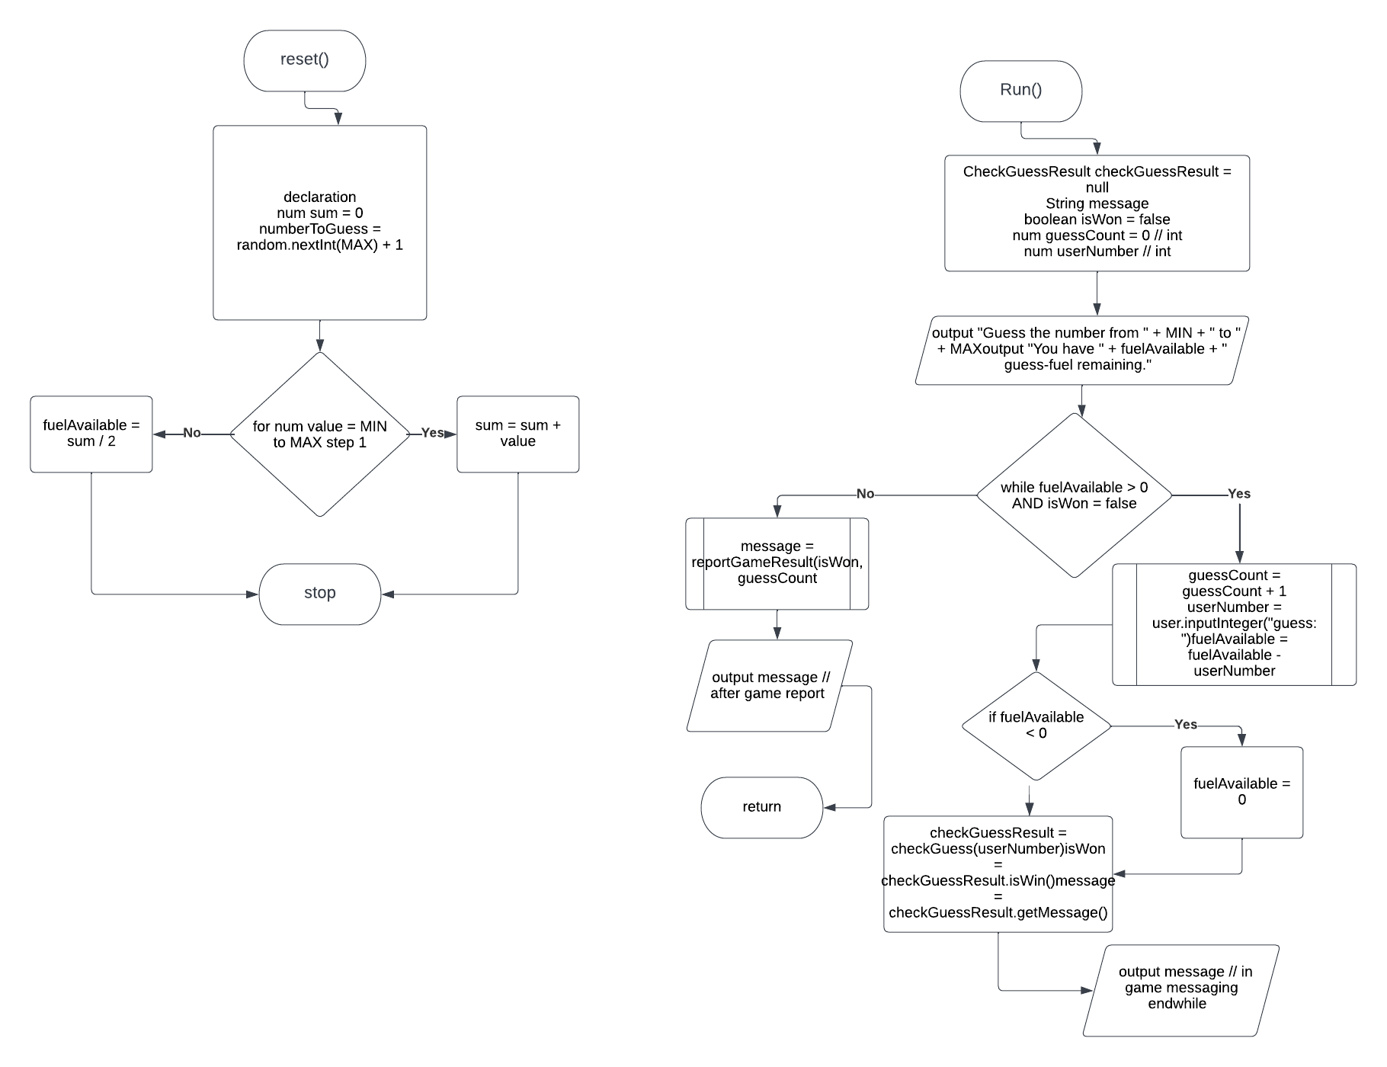Flow chart for run and reset method:

Test planes:

|  |  |  |  |  |  |
| --- | --- | --- | --- | --- | --- |
| For loop in method reset() value | value <= MAX ? | | sum | | Notes |
| 1 | Yes | | 1 | | Loop runs, sum is increased by 1 |
| 2 | Yes | | 3 | | Loop runs, sum is increased by 2 |
| 3 | Yes | | 6 | | Loop runs, sum is increased by 3 |
| 4 | Yes | | 10 | | Loop runs, sum is increased by 4 |
| 5 | Yes | | 15 | | Loop runs, sum is increased by 5 |
| 6 | Yes | | 21 | | Loop runs, sum is increased by 6 |
| 7 | Yes | | 28 | | Loop runs, sum is increased by 7 |
| 8 | yes | | 36 | | Loop runs, sum is increased by 8 |
| 9 | Yes | | 45 | | Loop runs, sum is increased by 9 |
| 10 | Yes | | 55 | | Loop runs, sum is increased by 10 |
| 11 | | No | | Loop stops | |

While loop in method run() trace table for user does guess answer:

|  |  |  |  |  |  |  |  |
| --- | --- | --- | --- | --- | --- | --- | --- |
| fuelAvailable | | isWon | fuelAvailable > 0 &&  isWon == false ? | | User input | | Notes |
| 27 | | false | Yes | | 5 | | Loop runs, user enters 5, fuelAvailable becomes 22, isWon remains false |
| 22 | | false | Yes | | 4 | | Loop runs, user enters 4, fuelAvailable becomes 18, isWon becomes true |
| 18 | true | | | no | | Loop gets over user wins | |

Do-While loop in method main() testing that program continues and exits:

|  |  |  |
| --- | --- | --- |
| User input | shouldContinue = CONTINUE_GAME ? | Notes |
| y | Yes | User entered “y” to continue the game, loop continues |
| n | no | User entered “n” to stopthe game, loop stops |

## While loop in method run() trace table for running out of fuel user does not guess answer:

|  |  |  |  |  |
| --- | --- | --- | --- | --- |
| fuelAvailable | isWon | fuelAvailable > 0 &&  isWon == false ? | User input | Notes |
| 27 | false | Yes | 10 | Loop runs, user enters 10, fuelAvailable becomes 17, isWon remains false |
| 17 | false | Yes | 10 | Loop runs, user enters 10, fuelAvailable becomes 7, isWon remains false |
| 7 | false | yes | 10 | Loop runs, user enters 10, fuelAvailable becomes 0, isWon remains false |
| 0 | false | no | - | Game over, asks user if want to play again. |
|  |  |  |  |  |
|  |  |  |  |  |
|  |  |  |  |  |

# Question(s)

1. (Reflective) Examine method reset() and re-write the for loop as a while loop using pseucode and submit this as part of your write up in the MS Word document.
   * Which is your preferred version of the loop, and why? (Compare and contrast from perspective of ease of use and ease of reading between a for-loop, and a while-loop that both solve the same problem).
     + In my point of view do while loop is more suite able as for me it is easier to control flow in that.
2. (Technical) When using a for loop the loop control variable is written in-line within the loop header.
   * What is the scope of this variable (class-scope, local-scope, or block-level-scope)?
   * Can you access the loop control variable to print the last value it held below the loop body (yes/no)?

# Screen shot of running program:

